Ross Woodstock
Executive Coach—Leadership Training—Author—Speaker

Contact:
517-410-7636
ross@rosswoodstockcoaching.com
www.rosswoodstockcoaching.com

Short Bio

Ross Woodstock’s work as an executive coach and leadership consultant has impacted thousands of leaders in business, government, education, healthcare and non-profit organizations. Ross has dedicated his career to helping leaders realize their full potential.

Ross Woodstock is also the author of Lead to Lift Up Others: Leadership Insights from a Caregiver’s Journey in which he shares 12 leadership insights from his years as a caregiver for his wife Sharen—a victim of a devastating stroke that changed both of their lives.

Long Bio

Ross Woodstock is an author, speaker, executive coach and leadership consultant with a desire to impact the lives of leaders seeking to realize their full potential. His career journey included a 27-year stint in the media industry, starting as a radio reporter and eventually rising to the position of President and General Manager of the CBS TV affiliate in Lansing. He has also served as a communications strategist with Kolt Communications, Inc. For the past decade, Ross has worked with numerous organizations in the private and public sector to help develop and equip their leaders to meet the challenges in today’s organizational culture.

Ross wrote Lead to Lift up Others after observing how his wife, Sharen has faced the numerous health challenges she has faced. Many of the characteristics she has courageously demonstrated in life are the same characteristics displayed by the best leaders in the world. There are 53 million unpaid caregivers in our country today, a number that will grow dramatically in the next few years.

The physical, mental and financial toll that unpaid caregivers often experience is having a significant impact on them and in the workplace. In his work as an author and public speaker, Ross is dedicated to helping organizations understand how building a Care Culture that better supports their employee caregivers will help the organizations attract and retain the best talent and how to do so that cut costs related to absenteeism, turnover and lost productivity.
Ross is also a certified Leadership Fitness Trainer through the Fit Leader’s Program™, which he continues to teach within several organizations including the State of Michigan, Michigan Department of Corrections, GreenStone Farm Credit Services and the Michigan Health and Hospital Association. He is a co-facilitator in the Leadership Lansing program through the Lansing Regional Chamber of Commerce. He is credentialed in the Five Behaviors of a Cohesive Team™ and regularly conducts team building trainings within organizations. He is also a certified DiSC instructor.
Ross has a master’s degree in Management and Administrative Services from the University of Texas at Dallas. He received a bachelor’s degree in Management of Human Resources from Spring Arbor College. In 1995, the Spring Arbor Alumni Association honored Ross with its Professional Excellence Award, citing him for “outstanding professional and community contributions and for achieving honor and distinction for Spring Arbor College.”

Keynotes
Unpaid Caregivers at Work
How Your Organization Can Win the Talent Battle by Building a Culture of Care
The challenges faced by the growing numbers of unpaid caregivers in the United State are taking their toll on organizations already struggling to attract and retain talent. The caregiving crisis is threatening the well-being of the workforce and the diminishing productivity and engagement in organizations. Skyrocketing costs associated with talent that is distracted, stressed, and in many cases suffering burnout is eroding profitability. There is hope in the midst of these
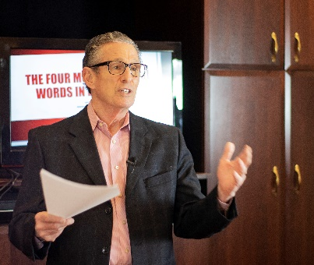

challenges that employers can turn the caregiving crisis to their advantage and help them win the talent battle.
This keynote gives you the opportunity to hear how to conquer the caregiving crisis from someone who has been on the frontlines as an unpaid caregiver, author, speaker and trainer. Your organization can win the talent battle by creating a culture that will allow you to retain the best talent. The resulting improvement in engagement and productivity will also cut the escalating costs associated with the caregiving crisis.

The Four Most Powerful Words in Leadership
One of the greatest leadership lessons Ross learned during the early years of my career was the importance of four little words in our lives. They are simple words, really. But the cumulative effect of these words on an organization, a community and, yes, even the world, can be amazing. If you live by these words every day—not just memorize them and say them, but truly live them out in your own leadership life—these four words will make a significant difference in your ability to make a difference in your organization, your ability to build great teams, your ability to build a stronger, more profitable business, and most importantly your ability to make a difference in the lives of those around you.
I believe in you.
Let Ross show you how you can lift up of others by investing yourself into their lives. You can accomplish this by letting them know you believe in them, celebrating their success, remaining positive in the face of chronic negativity, demonstrating resilience, encouraging those around you, remaining humble, maintaining an attitude of gratitude and committing to a strong foundation of values.

Are you willing to be that leader?

Our world desperately needs leaders who can embrace and celebrate differences, encourage multiple points of view,
challenge the status quo and push the envelope on innovative approaches to problems. We need leaders who can unify where divisions exist, collaborate when communication breaks down, and find common ground to create solutions that others say cannot be achieved.

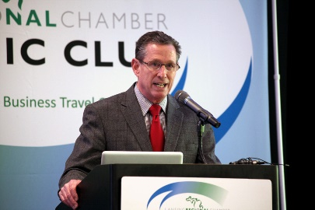

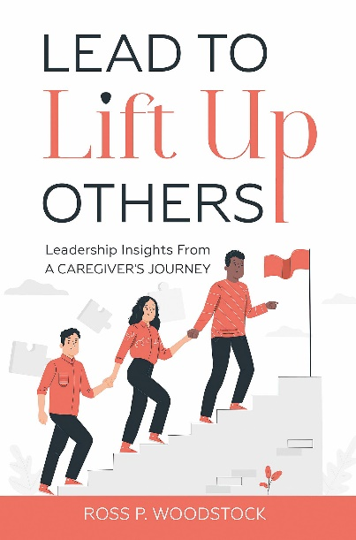

Ross will challenge you to is to be the type of leader the world needs. Resolve to change the world one person and one day at
a time. Make a decision to take charge to the best of your ability in your everyday world.

But, Wait. There’s More!

After his keynote Ross is available to provide amazing breakout sessions that are highly interactive, engaging and fun. Topics include:

- Unpaid Caregivers at Work Breakout: The ROI from Building a Care Culture
- Winning the Talent Battle: Beat the Burnout Blues
- How to Build an Empowerment Culture
- The Power of Positivity: Overcoming Negative Voices in the Workplace
- Your Leadership Legacy
- Develop. Develop. Develop. Bringing Out the Best in Others

Praise for Lead to Lift Up Others

“Ross takes you on his personal journey as a caregiver for Sharen and wonderfully connects his unexpected life experiences and his 27 years in broadcast media to leadership insights. Ross’ core values of family and faith are strongly reflected in how he approached life challenges and pursued new career opportunities to help individuals strengthen leadership development. You will take away key strategies in improving your leadership skills while assessing new approaches in working with, growing and investing in your team.”
Tim Daman
President & CEO
Lansing Regional Chamber of Commerce

